Business Plan for “Knock Down” 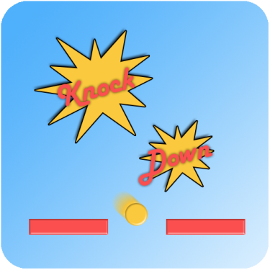

Developed by <OneJoltGames>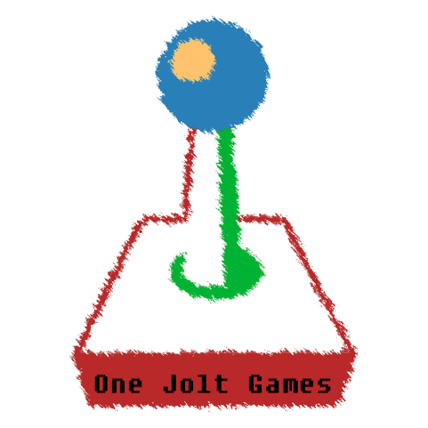

Table of Contents

Executive Summary 3

Business of the company 3

Product Description 3

Market 3

Competition 3

Marketing 3

Organisation 3

SWOT Analysis 3

Financial Requirements 3

Contracts and Legal Implications 3

Product Description 4

Examples of business plans 9

## Executive Summary

## Business of the company

**Business summary and History**

One Jolt Games Inc. (One Jolt Games) is an Indie Game Development start-up company. The company develops mobile and computer based products that feature fun, replay-able games. The company’s first proposed flagship product, Knock Down, is a very fun and addictive mobile game catered to a large chunk of the intended platform which incorporates <Some elements> elements for users.

One Jolt Games is an English company based out of Cheltenham, Gloucestershire.

## Product Description

**Detailed Description of Product**

Knock Down is a 2d physics-based ball featuring obstacles such as spikes and tornados that the player has to avoid. The <Description of game> game is set to be available on the Google play store by January 2015.

## Market

**Target Market**

## The primary target market of knock down is the <some %> of casual gamers that like simple and intuitive games. <State most effective ways of advertisement for group mentioned before>.<Where does the target market primarily reside?>.

## Estimated Sales

## Based on the budget of £100,000, blah blah blah.

**Rules of Purchase**

## The quality of the game is critical in that it must contain the minimum threshold of credibility, challenge, uniqueness and shareability for the user to try and continue as a regular user.

## Competition

**Direct Competitors**

## Market share’s direct competitors are game developers including King, Rovio, <mobile game devs>

The primary strength of large companies such as King and Rovio is that they possess enormous market share

**Indirect Competitors**

## Marketing

**Positioning**

Knockdown will be positioned by its product attributes. The customer will see the game as unique in that nothing like it exists.

## Organisation

The current company ownership of One Jolt Games Inc. is as follows;

100percent Mohit Gidwani

## SWOT Analysis

Strengths

* Popular Product offering
* Near unlimited marketing potential

Weaknesses

* Video game learning curve for owners

Opportunities

* Local market expansion

Threats

* Selection of market
* Market entry by competitors

## Financial Requirements

## Contracts and Legal Implications

**Executive summary**

**Business of the company**

## Product Description

* **Attach a tagline to your game**
  + **Tagline:** *“Watch out for the spike, avoid the pitfalls”*
* **Define a genre**
  + **Arcade, Casual**
* **Quality Screenshots are essential**
* 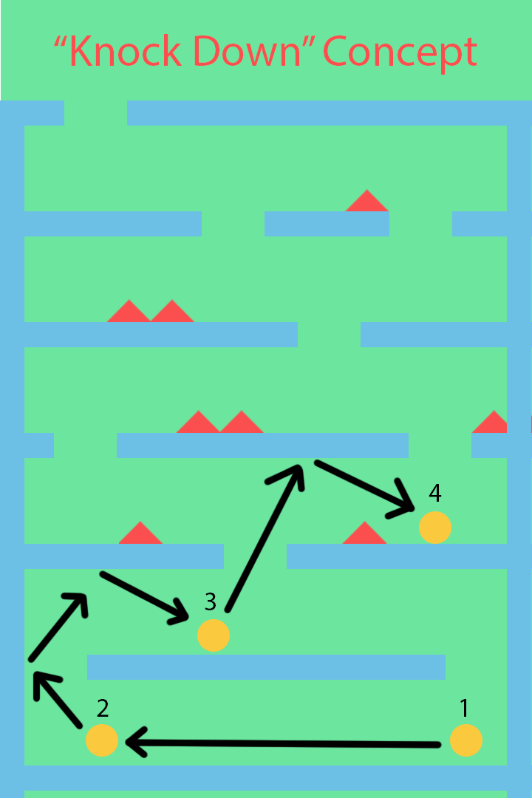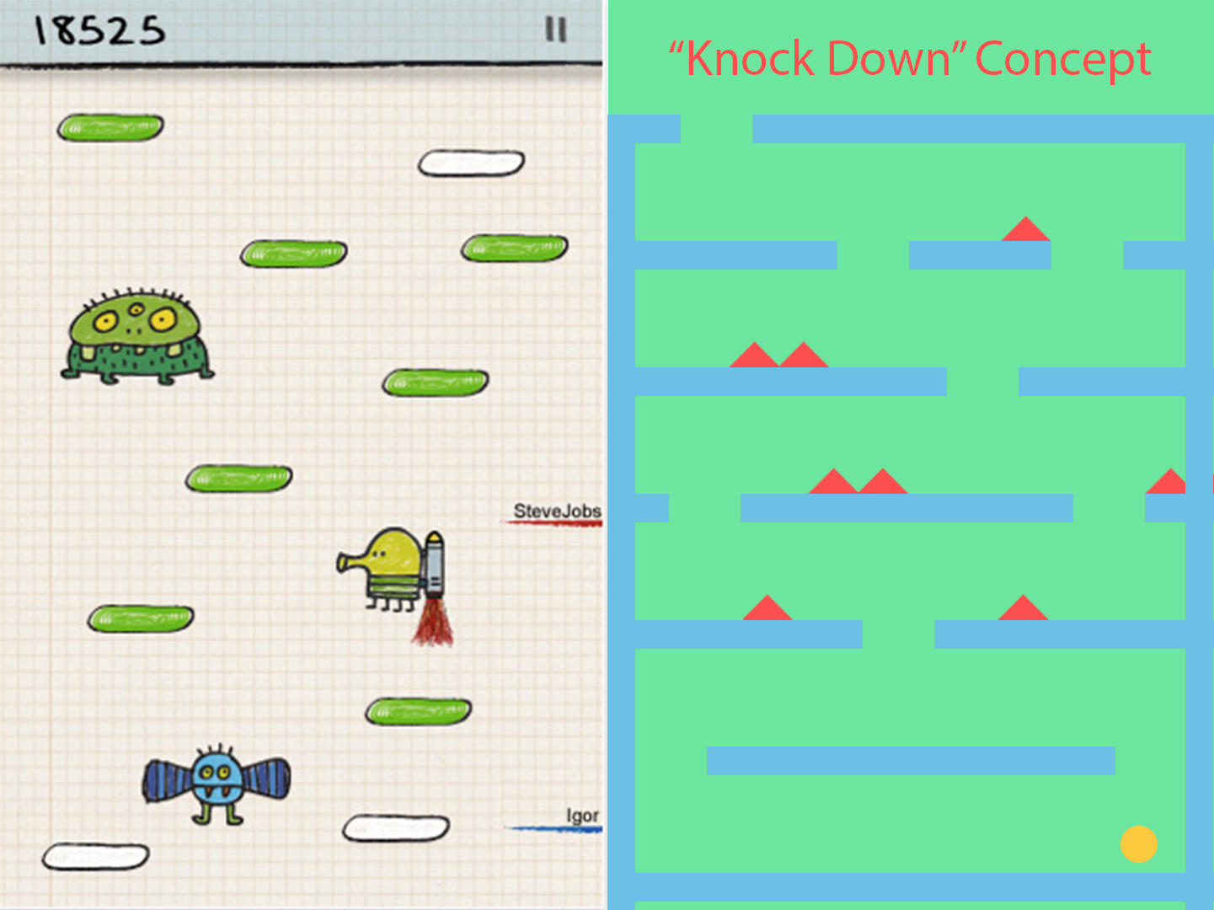

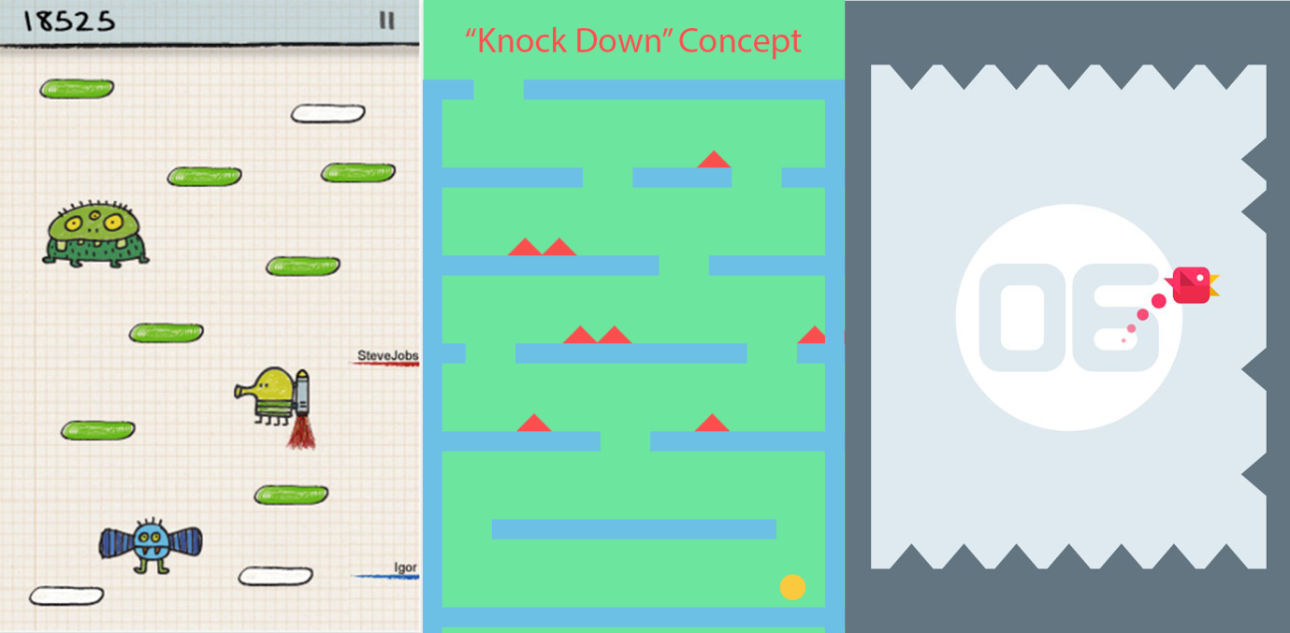

* **USP – Unique Selling Point**
* **Who is the Audience?**
  + Casual Gamers aged 6 and above.
* **What is its rating?**
  + **4/5**
* **How long will it take to play?**
  + 5 secs to 10 mins
* **Why should people play your game?**
  + Easy to pick up, simple controls
* **Aim for around 5 “back-of-the-box” goals**
  + Collect stars
  + Avoid spikes
  + Bounce
  + Avoid tornados
  + Shake to survive
* **What is it like to play your game?**
* **What options are available in your game?**

**Market**

* **How is your game being distributed?**
  + Via Google play store.
* **Free-mium**
  + Free to download, pay to gain lives, pay for skins, extra content
* **How much do you think you could make in each market each year?**
  + £500 assuming 2 downloads a day

**Competition**

* **Who are the big players in the mobile industry?**
  + - King, Rovio, Ketchapp
    - **What games have they released?**
      * Candy Crush, Angry Birds, Don’t touch the spikes
* **Similar titles?**
  + - Don’t touch the spikes & doodle jump

**Marketing**

* **Which categories does your game fit into?**
  + - Casual, Arcade
* **How will you obtain sales?**
  + - Pay to gain lives, paying for skins
* **Enticements?**
  + - Time waster, High score, Reflex challenge
* **How do you get the public involved?**
  + - Adverts built into the game, Artwork competition,
* **Create downloadable advertisement. Presskit() template**
  + - **Being done-ish**
* **Social media presence, FB? Twitter?**
  + - A facebook page has been created
* **Youtube channel for progress?**
  + - Execution and management would eat up a lot of time
* **Which major indie development website can you publicise your work on?**
  + - Indiegamer.com, humble bundle
* **How do you intend to maintain this?**
  + - Weekly/monthly check
* **List of keywords that describe your game.**
  + - Bounce, simple, spike, unity,

**More to be done in the coming days. ☺**

**Organisation**

**SWOT Analysis**

**Financial Requirements**

**Contracts & Legal Implications**

**Potential names:**

**The incredible rage ball**

**Golden Knock Down**

**Future References:**

Facebook/Social media and more:

<http://gamedevlaw.org/2013/10/15/would-you-like-color-options-with-that-games-as-a-service/>

Extras:

Commercially releasing a game using adobe software using student and teachers license is allowed. However the uni uses a volume license which make it so that if you release a game commercially using them, it belongs to the uni. Interms of ownership this would be an issue for people creating games using flash, but would work if using unity and gimp(image editing).

<http://mashable.com/2009/11/23/avoiding-social-media-distraction/> - Media tips

 “The opinions and positions expressed are my own and don’t necessarily reﬂect those of Eastman Kodak Company.”

<http://www.gamasutra.com/view/feature/131662/writing_a_business_plan_for_.php> - Article on writing business plan

<http://www.bplans.co.uk/computer_programming_business_plan/executive_summary_fc.cfm> - Same

<http://www.referenceforbusiness.com/business-plans/Business-Plans-Volume-10/Network-Game-Centers.html> - Another one

<http://www.gamedonia.com/marketing/pitch-games-investors> - Could help

<http://www.sloperama.com/advice/idea.htm> - Could help in several aspects

<http://www.newzoo.com/trend-reports/mobile-games-trend-report/> - Market Data

<http://www.slideshare.net/Newzoo/2014-global-games-market-webinar> - Market Data

<http://www.bigfishgames.com/blog/2014-android-iphone-ipad-tablet-mobile-video-game-stats/>

## Examples of business plans

<http://www.bplans.com/computer_programming_business_plan/executive_summary_fc.php> - Another example of plan

4 Game Inc (pdf included)

Rolling Video Games(pdf included)

Third one(pdf)

**Change log (ish)**

Endless runner concept not being used as programming is too complicated and game needs it to be restricted whilst concept is too free.